**Troop 728/5728 Scout Leadership Positions**

**Duties and Responsibilities**

**Leading the Way**

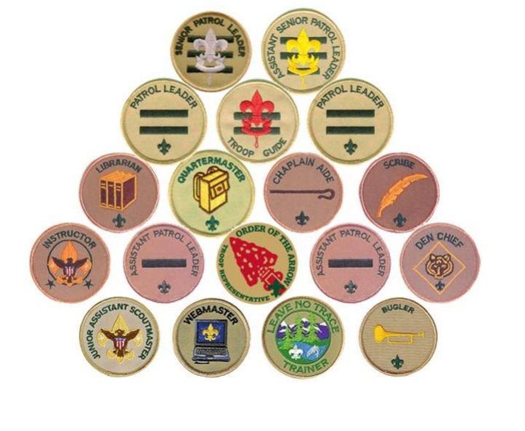

**February 2025**

**Leading the way, what does that mean?**

Think about being a Cub Scout. You came to den meetings and did a lot of different and fun things. But who decided what to do and who planned the activities? The Den Leaders, right?

Sports teams are a lot of fun, too. But who decides who plays what position, who’s on the starting lineup and when to substitute? The coach, right?

There is one thing that makes Scouting different from all other youth groups. Do you know what it is?

Well, it is not the uniform. Every soccer, basketball, and baseball team has a uniform.

**What makes Scouting special is that YOU make the decisions!**

That’s right! YOU run the troop. Baden -Powell made it very plain in Aids to Scoutmastership when he wrote,

“The best progress is made in those Troops where power and responsibility are really put into the hands of the Patrol Leaders.”

This is real decision making power. And, it's not just Patrol Leaders. All of the troop leadership positions have a hand in making the Troop run. As a troop leader you will:

* Plan and run troop meetings,
* Pick troop outings, where to camp, what to do,
* Plan advancement opportunities for all troop members
* Select High-Adventure programs
* Determine troop policy
* Help other Scouts along the trail to Eagle.

Sound cool? It really is! The adults are there to provide support but YOU will be making the decisions.

Because being a leader is more than just sewing on a patch and giving out orders, we have put together job descriptions for the troop leadership positions. They will give you a good idea of what each job is all about and what you will be required to do.

**Here's how to be considered for a position**

First read the job descriptions, qualifications, and job responsibilities. Then decide what you want to do and talk it over with your parents. You can also talk it over with other Scouts who have served in that position. Finally, get a troop job application form, fill it out, have your parent(s) read and sign it, and turn it in to the Scoutmaster.

So, are you ready to "Lead the way"? We sure hope so!

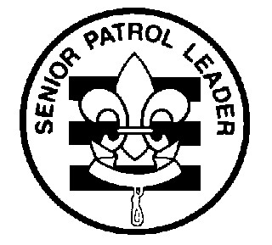**Troop 728/5728**

**Leadership Position Description – SENIOR PATROL LEADER**

**GENERAL INFORMATION**

**Type:** Elected by the members of the troop

**Term:** 6 months

Reports to: Scoutmaster

**Description:** The Senior Patrol Leader is elected by the scouts to represent them as the top junior leader in the troop.

**Comments:** The Senior Patrol Leader is the focal point of the troop. The SPL needs to attend as close to all troop functions as possible. One of the major parts of the SPL's job is to appoint other troop leaders. The Scout must choose leaders who are able, not just friends or other popular Scouts.

**QUALIFICATIONS**

**Age:** 13 or older

**Rank:** Life and higher -or- Star with Scoutmaster approval

**Experience:** Previous service as SPL / ASPL -or- with Scoutmaster approval

**Attendance:** Two years of prior attendance with Troop 728/5728. 75% attendance over previous 6 months

**Training:** Have attended JLT -and- NYLT, Polaris or SOGUS -or- with Scoutmaster approval

**PERFORMANCE REQUIREMENTS**

**Training:** You must attend the troop Junior Leader Training even if you have attended in the past.

**Attendance:** You are expected to attend 85% of all troop meetings, Patrol Leaders' Council meetings, outings, and service projects. If your attendance is low, or if you have three (3) unexcused absences in a row, you can be removed from office.

**Effort:** You are expected to give this job your best effort.

**GENERAL LEADERSHIP RESPONSIBILITIES**

**Uniform:** Set the example by wearing your uniform correctly. This means that you will wear all of the parts of the troop uniform, shirttail tucked in, with all required badges in their correct locations.

**Behavior:** Set the example by living the Scout Oath and Law in your everyday life. Show Scout Spirit in everything you say and do. Remember that you represent the troop in everything that you do. LEAD BY YOUR EXAMPLE!

**Attendance**: Set the example by being an active Scout. Be on-time for meetings and activities. You must call the Scoutmaster if you are not going to be at a meeting or if you suddenly have to miss an outing. You also need to make sure that the Assistant Senior Patrol Leader is ready to assume your responsibilities.

**SPECIFIC LEADERSHIP RESPONSIBILITIES**

* Runs all troop meetings, events, activities, and the annual program planning conference.
* Runs the Patrol Leader's Council meeting.
* Prepares written meeting agendas, and ensures information is passed on to all members.
* Appoints other troop junior leaders with the advice and counsel of the Scoutmaster.
* Assigns duties and responsibilities to junior leaders, ensures assignments are completed.
* Assists the Scoutmaster with Junior Leader Training.

Print Name __________________________ Signature ____________________________ Date ________

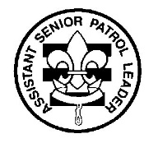**Troop 728/5728**

**Leadership Position Description – ASSISTANT SENIOR PATROL LEADER**

**GENERAL INFORMATION**

**Type:** Appointed by the Senior Patrol Leader, with the approval of the Scoutmaster

**Term:** 6 months

**Reports to:** Senior Patrol Leader

**Description:** The Assistant Senior Patrol Leader is the second highest ranking patrol leader in the troop. The Assistant Senior Patrol Leader acts as the Senior Patrol Leader in the absence of the SPL or when called upon. ASPL also provides leadership to other junior leaders in the troop.

**Comments:** The most important part of the ASPL position is working with the other junior leaders. The ASPL should be familiar with the other positions and stay current with the work being done.

**QUALIFICATIONS**

**Age:** 12 or older

**Rank:** Star and higher -or- 1st Class with Scoutmaster approval

**Experience:** none

**Attendance:** One year prior attendance in the troop. >65% over the previous 6 months

**PERFORMANCE REQUIREMENTS**

**Training:** You must attend the troop Junior Leader Training even if you have attended in the past.

**Attendance:** You are expected to attend 75% of all troop meetings, Patrol Leaders' Council meetings, outings, and service projects. If your attendance is low, or if you have three (3) unexcused absences in a row, you can be removed from office.

**Effort:** You are expected to give this job your best effort.

**GENERAL LEADERSHIP RESPONSIBILITIES**

**Uniform:** Set the example by wearing your uniform correctly. This means that you will wear all of the parts of the troop uniform, shirttail tucked in, with all required badges in their correct locations.

**Behavior:** Set the example by living the Scout Oath and Law in your everyday life. Show Scout Spirit in everything you say and do.

**Attendance:** Set the example by being an active Scout. Be on-time for meetings and activities. You

must call the Senior Patrol Leader or Scoutmaster if you are not going to be at a meeting or if you suddenly have to miss an outing. You also need to make sure that someone will assume your responsibilities.

**SPECIFIC LEADERSHIP RESPONSIBILITIES**

* Helps the Senior Patrol Leader lead meetings and activities.
* Be prepared to run the troop in the absence of the Senior Patrol Leader.
* Helps train and supervise the Troop Scribe, Quartermaster, Instructor, Librarian, Historian, and Chaplin Aide.
* Works with Outings Asst. Scoutmaster to coordinate troop activities and outings.
* Coordinates assignments and projects assigned by the Senior Patrol Leader.
* Serves as a member of the Patrol Leader's Council.
* Actively supports the leadership efforts of the Senior Patrol Leader as a part of the leadership team in all dealings with the troop.

Print Name __________________________ Signature ____________________________ Date ________

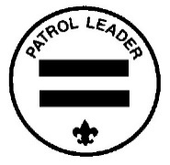**Troop 728/5728**

**Leadership Position Description – PATROL LEADER**

**GENERAL INFORMATION**

**Type:** Elected by members of the patrol

**Term:** 6 months (or other agreement within patrol)

**Reports to:** Senior Patrol Leader

**Description:** The Patrol Leader is the elected leader of the patrol. The Patrol Leader represents their patrol on the Patrol Leader's Council.

**Comments:** The Patrol Leader may easily be the most important job in the troop. He has the closest

contact with the patrol members and is in the perfect position to help and guide them. The Patrol Leaders, along with the Senior Patrol Leader and Assistant Senior Patrol Leader are the primary members of the Patrol Leaders' Council.

**QUALIFICATIONS**

**Age:** none

**Rank:** none

**Experience:** none

**Attendance:** >50% over previous 6 months

**PERFORMANCE REQUIREMENTS**

**Training:** You must attend the troop Junior Leader Training even if you have attended in the past.

**Attendance:** You are expected to attend 75% of all troop meetings, Patrol Leaders' Council meetings, outings, and service projects. If your attendance is low, or if you have three (3) unexcused absences in a row, you can be removed from office.

**Effort:** You are expected to give this job your best effort.

**GENERAL LEADERSHIP RESPONSIBILITIES**

**Uniform:** Set the example by wearing your uniform correctly. This means that you will wear all parts of the troop uniform, shirttail tucked in, with all required badges in their correct locations.

**Behavior:** Set the example by living the Scout Oath and Law in your everyday life. Show Scout Spirit in everything you say and do.

**Attendance:** Set the example by being an active Scout. Be on-time for meetings and activities. You must call the Senior Patrol Leader or Scoutmaster if you are not going to be at a meeting or if you suddenly have to miss an outing. You also need to make sure that the Assistant Patrol Leader is ready to assume your responsibilities.

**SPECIFIC LEADERSHIP RESPONSIBILITIES**

* Appoints the Assistant Patrol Leader.
* Represents the patrol on the Patrol Leader's Council.
* Plans and steers patrol meetings.
* Helps Scouts advance.
* Acts as the chief recruiter of new Scouts.
* Keeps patrol members informed.
* Knows what his patrol members and other leaders can do.
* Coordinates and ensures patrol planning of outings and activities, (menu, duty rosters, equip. etc.)

Print Name __________________________ Signature ____________________________ Date ________

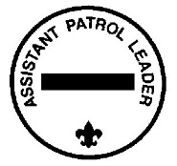**Troop 728/5728**

**Leadership Position Description – ASSISTANT PATROL LEADER**

**GENERAL INFORMATION**

**Type:** Appointed by the Patrol Leader

**Term:** 6 months (or other agreement within patrol)

**Reports to:** Patrol Leader

**Description:** The Assistant Patrol Leader is appointed by the Patrol Leader and leads the patrol in his absence.

**Comments:** Substituting for the Patrol Leader is only part of the Assistant Patrol Leader's job. The Assistant Patrol Leader actively helps run the patrol.

**QUALIFICATIONS**

**Age:** none

**Rank:** none

**Experience:** none

**Attendance:** >50% over previous 6 months

**PERFORMANCE REQUIREMENTS**

**Training:** You must attend the troop Junior Leader Training even if you have attended in the past.

**Attendance:** You are expected to attend 65% of all troop meetings, Patrol Leaders' Council meetings, outings, and service projects. If your attendance is low, or if you have three (3) unexcused absences in a row, you can be removed from office.  **Effort:** You are expected to give this job your best effort.

**GENERAL LEADERSHIP RESPONSIBILITIES**

**Uniform:** Set the example by wearing your uniform correctly. This means that you will wear all of the parts of the troop uniform, shirttail tucked in, with all required badges in their correct locations.

**Behavior:** Set the example by living the Scout Oath and Law in your everyday life. Show Scout Spirit in everything you say and do.

**Attendance:** Set the example by being an active Scout. Be on-time for meetings and activities. You must call the Senior Patrol Leader or Scoutmaster if you are not going to be at a meeting or if you suddenly have to miss an outing. You also need to make sure that someone will assume your responsibilities.

**SPECIFIC LEADERSHIP RESPONSIBILITIES**

* Helps the Patrol Leader plan and steer patrol meetings and activities.
* Helps the Patrol Leader keep patrol members informed.
* Helps the patrol get ready for all troop activities.
* Represents his patrol at Patrol Leader's Council meetings when the Patrol Leader cannot attend.
* Lends a hand controlling the patrol and building patrol spirit.

Print Name __________________________ Signature ____________________________ Date ________

**Troop 728/5728**

**Leadership Position Description – DEN CHIEF**

**GENERAL INFORMATION**

**Type:** Appointed by the Scoutmaster

**Term:** 1 year

**Reports to:** Scoutmaster and Den Leader

**Description:** The Den Chief works with the Cub Scouts, Webelos Scouts, and Den Leaders in the Cub Scout pack.

**Comments:** The Den Chief provides a knowledge of games and Scout skills that many Den Leaders lack. The Den Chief is also a recruiter for the troop. This function is important because no troop can thrive without new members and most new members will come from Cub Scouting.

**QUALIFICATIONS**

**Age:** 12 or older

**Rank:** 1st Class or higher

**Experience:** none

**Attendance:** >50% over previous 6 months

**PERFORMANCE REQUIREMENTS**

**Training:** You must attend the troop Junior Leader Training even if you have attended in the past.

**Attendance:** You are expected to attend 65% of all troop meetings, Patrol Leaders' Council meetings, outings, and service projects. If your attendance is low, or if you have three (3) unexcused absences in a row, you can be removed from office. In terms of attendance with your den, you are expected to attend 80% of den meetings and pack functions. You must inform the Den Leader if you will be absent.

**Effort:** You are expected to give this job your best effort.

**GENERAL LEADERSHIP RESPONSIBILITIES**

**Uniform:** Set the example by wearing your uniform correctly. This means that you will wear all of the parts of the troop uniform, shirttail tucked in, with all required badges in their correct locations.

**Behavior:** Set the example by living the Scout Oath and Law in your everyday life. Show Scout Spirit in everything you say and do.

**Attendance:** Set the example by being an active Scout. Be on-time for meetings and activities. You

must call the Senior Patrol Leader or Scoutmaster if you are not going to be at a meeting or if you suddenly have to miss an outing. You also need to make sure that someone will assume your responsibilities.

**SPECIFIC LEADERSHIP RESPONSIBILITIES**

* Knows the purposes of Cub Scouting
* Helps Cub Scouts advance through Cub Scout ranks.
* Encourages Cub Scouts to join a Scout troop upon graduation.
* Assists with activities in the den meetings.
* Is a friend to the scouts in the den.
* Helps out at weekly den meetings and monthly pack meetings.
* Meets with adult members of the den, pack, and troop as necessary.

Print Name __________________________ Signature ____________________________ Date ________

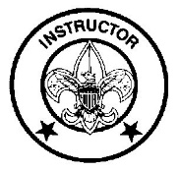**Troop 728/5728**

**Leadership Position Description – INSTRUCTOR**

**GENERAL INFORMATION**

**Type:** Appointed by the Scoutmaster

**Term:** 6 months

**Reports to:** Scoutmaster

**Description:** The instructor teaches Scouting skills.

**Comments:** The instructor will work closely with both the Troop Guide and with the Assistant Scoutmaster for new Scouts. The instructor does not have to be an expert but should be able to teach the Scoutcraft skills needed for Tenderfoot, Second Class, and First Class ranks. The troop can have more than one instructor.

**QUALIFICATIONS**

**Age:** 13 or older

**Rank:** 1st Class or higher

**Experience:** none

**Attendance:** >50% over previous 6 months

**PERFORMANCE REQUIREMENTS**

**Training:** You must attend the troop Junior Leader Training even if you have attended in the past.

**Attendance:** You are expected to attend 75% of all troop meetings, Patrol Leaders' Council meetings, outings, and service projects. If your attendance is low, or if you have three (3) unexcused absences in a row, you can be removed from office.  **Effort:** You are expected to give this job your best effort.

**GENERAL LEADERSHIP RESPONSIBILITIES**

**Uniform:** Set the example by wearing your uniform correctly. This means that you will wear all of the parts of the troop uniform, shirttail tucked in, with all required badges in their correct locations.

**Behavior:** Set the example by living the Scout Oath and Law in your everyday life. Show Scout Spirit in everything you say and do.

**Attendance:** Set the example by being an active Scout. Be on-time for meetings and activities. You must call the Senior Patrol Leader or Scoutmaster if you are not going to be at a meeting or if you suddenly have to miss an outing. You also need to make sure that someone will assume your responsibilities.

**SPECIFIC LEADERSHIP RESPONSIBILITIES**

* Teaches basic Scouting skills in troop and patrols.

Print Name __________________________ Signature ____________________________ Date ________

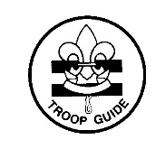**Troop 728/5728**

**Leadership Position Description – TROOP GUIDE**

**GENERAL INFORMATION**

T**ype:** Appointed by the Scoutmaster

**Term:** 6 months

**Reports to:** Scoutmaster

**Description:** The Troop Guide works with new Scouts. The Troop Guide helps them feel comfortable and earn their First Class rank in their first year.

**Comments:** The first year as a Scout is a critical time with new places, new people, new rules, and new activities. The Troop Guide is a friend to the new Scouts and makes first year fun and successful. This is an important position.

**QUALIFICATIONS**

**Age:** 13 or older

**Rank:** 1st Class or higher

**Experience:** none

**Attendance:** 75% over previous 6 months

**PERFORMANCE REQUIREMENTS**

**Training:** You must attend the troop Junior Leader Training even if you have attended in the past.

**Attendance:** You are expected to attend 75% of all troop meetings, Patrol Leaders' Council meetings, outings, and service projects. If your attendance is low, or if you have three (3) unexcused absences in a row, you can be removed from office.  **Effort:** You are expected to give this job your best effort.

**GENERAL LEADERSHIP RESPONSIBILITIES**

**Uniform:** Set the example by wearing your uniform correctly. This means that you will wear all of the parts of the troop uniform, shirttail tucked in, with all required badges in their correct locations.

**Behavior:** Set the example by living the Scout Oath and Law in your everyday life. Show Scout Spirit in everything you say and do.

**Attendance:** Set the example by being an active Scout. Be on-time for meetings and activities. You must call the Senior Patrol Leader or Scoutmaster if you are not going to be at a meeting or if you suddenly have to miss an outing. You also need to make sure that someone will assume your responsibilities.

**SPECIFIC LEADERSHIP RESPONSIBILITIES**

* Introduces new Scouts to troop operations.
* Guides new Scouts through early Scouting activities
* Shields new Scouts from harassment by older Scouts.
* Helps new Scouts earn First Class in their first year.
* Teaches basic Scout skills.
* Coaches the patrol leader of the new Scout patrol on his duties.
* Works with the patrol leader at Patrol Leaders' Council meetings.
* Attends Patrol Leaders' Council meetings with the patrol leader of the new Scout patrol.
* Assists the Assistant Scoutmaster with training.
* Counsels individual Scouts on Scouting challenges.

Print Name __________________________ Signature ____________________________ Date ________

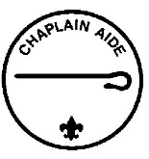**Troop 728/5728**

**Leadership Position Description – CHAPLIN AIDE**

**GENERAL INFORMATION**

**Type:** Appointed by the Senior Patrol Leader with approval of Scoutmaster

**Term:** 6 months

**Reports to:** Assistant Senior Patrol Leader

**Description:** The Chaplin Aide works with the Troop Chaplin to meet the religious needs of Scouts in the troop. The Chaplin Aide also works to promote the religious awards program.

**Comments:** "Duty to God" is one of the core beliefs of Scouting. The Chaplin Aide helps everyone in the troop by preparing short religious observations for campouts and other functions. The Chaplin Aide does not always lead the observation and can have other troop members help.

**QUALIFICATIONS**

**Age:** none

**Rank:** none

**Experience:** none

**Attendance:** >50% over the previous 6 months

**PERFORMANCE REQUIREMENTS**

**Training:** You must attend the troop Junior Leader Training even if you have attended in the past.

**Attendance:** You are expected to attend 65% of all troop meetings, Patrol Leaders' Council meetings, outings, and service projects. If your attendance is low, or if you have three (3) unexcused absences in a row, you can be removed from office.  **Effort:** You are expected to give this job your best effort.

**GENERAL LEADERSHIP RESPONSIBILITIES**

**Uniform:** Set the example by wearing your uniform correctly. This means that you will wear all of the parts of the troop uniform, shirttail tucked in, with all required badges in their correct locations.

**Behavior:** Set the example by living the Scout Oath and Law in your everyday life. Show Scout Spirit in everything you say and do.

**Attendance:** Set the example by being an active Scout. Be on-time for meetings and activities. You must call the Senior Patrol Leader or Scoutmaster if you are not going to be at a meeting or if you suddenly have to miss an outing. You also need to make sure that someone will assume your responsibilities.

**SPECIFIC LEADERSHIP RESPONSIBILITIES**

* Assists the Troop Chaplin with religious services at troop activities.
* Tells Scouts about the religious emblem program for their faith.
* Makes sure religious holidays are considered during troop program planning.
* Helps plan for religious observance in troop activities.

Print Name __________________________ Signature ____________________________ Date ________

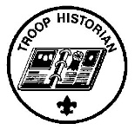**Troop 728/5728**

**Leadership Position Description – TROOP HISTORIAN**

**GENERAL INFORMATION**

**Type:** Appointed by the Senior Patrol Leader with approval of Scoutmaster

**Term:** 6 months

**Reports to:** Assistant Senior Patrol Leader

**Description:** The Troop Historian keeps a historical record or scrapbook of troop activities.

**Comments:** The true value of a good Historian does not show up until years later. The Historian provides material for displays and presentations of current activities. In addition, the work of the Historian provides a link with the past.

**QUALIFICATIONS**

**Age:** none

**Rank:** none

**Experience:** none, but interest in photography and writing is helpful

**Attendance:** >50% over the previous 6 months

**PERFORMANCE REQUIREMENTS**

**Training:** You must attend the troop Junior Leader Training even if you have attended in the past.

**Attendance:** You are expected to attend 65% of all troop meetings, Patrol Leaders' Council meetings, outings, and service projects. If your attendance is low, or if you have three (3) unexcused absences in a row, you can be removed from office.  **Effort:** You are expected to give this job your best effort.

**GENERAL LEADERSHIP RESPONSIBILITIES**

**Uniform:** Set the example by wearing your uniform correctly. This means that you will wear all of the parts of the troop uniform, shirttail tucked in, with all required badges in their correct locations.

**Behavior:** Set the example by living the Scout Oath and Law in your everyday life. Show Scout Spirit in everything you say and do.

**Attendance:** Set the example by being an active Scout. Be on-time for meetings and activities. You must call the Senior Patrol Leader or Scoutmaster if you are not going to be at a meeting or if you suddenly have to miss an outing. You also need to make sure that someone will assume your responsibilities.

**SPECIFIC LEADERSHIP RESPONSIBILITIES**

* Gathers pictures and facts about past troop activities and keeps them in a historical file or scrapbook.
* Takes care of troop trophies, ribbons, and souvenirs of troop activities.
* Keeps information about former members of the troop.

Print Name __________________________ Signature ____________________________ Date ________

**Troop 728/5728**

**Leadership Position Description – TROOP LIBRARIAN**

**GENERAL INFORMATION**

**Type:** Appointed by the Senior Patrol Leader with approval of Scoutmaster

**Term:** 6 months

**Reports to:** Assistant Senior Patrol Leader

**Description:** The Troop Librarian takes care of troop literature.

**Comments:** The library contains books of historical value as well as current materials. All together, the library is a troop resource worth hundreds of dollars. The Librarian manages this resource for the troop.

**QUALIFICATIONS**

**Age:** none

**Rank:** none

**Experience:** none

**Attendance:** >50% over the previous 6 months

**PERFORMANCE REQUIREMENTS**

**Training:** You must attend the troop Junior Leader Training even if you have attended in the past.

**Attendance:** You are expected to attend 65% of all troop meetings, Patrol Leaders' Council meetings, outings, and service projects. If your attendance is low, or if you have three (3) unexcused absences in a row, you can be removed from office.  **Effort:** You are expected to give this job your best effort.

**GENERAL LEADERSHIP RESPONSIBILITIES**

**Uniform:** Set the example by wearing your uniform correctly. This means that you will wear all of the parts of the troop uniform, shirttail tucked in, with all required badges in their correct locations.

**Behavior:** Set the example by living the Scout Oath and Law in your everyday life. Show Scout Spirit in everything you say and do.

**Attendance:** Set the example by being an active Scout. Be on-time for meetings and activities. You must call the Senior Patrol Leader or Scoutmaster if you are not going to be at a meeting or if you suddenly have to miss an outing. You also need to make sure that someone will assume your responsibilities.

**SPECIFIC LEADERSHIP RESPONSIBILITIES**

* Sets up and takes care of a troop library
* Keeps records of books and pamphlets owned by the troop.
* Adds new or replacement items as needed.
* Keeps books and pamphlets available for borrowing.
* Keeps a system for checking books and pamphlets in and out.
* Follows up on late returns.
* Issues vouchers for purchase of used merit badge books.

Print Name __________________________ Signature ____________________________ Date ________

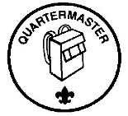**Troop 728/5728**

**Leadership Position Description – TROOP QUARTERMASTER**

**GENERAL INFORMATION**

**Type:**Appointed by the Senior Patrol Leader with approval of Scoutmaster

T**erm:** 6 months

**Reports to:** Assistant Senior Patrol Leader

**Description:** The Troop Quartermaster keeps track of troop equipment and sees that it is in good working order.

**Comments:** The Quartermaster does most of his work around campouts. There are times when the Quartermaster has to be available to check equipment in and out.

**QUALIFICATIONS**

**Age:** none

**Rank:** none

**Experience:** none

**Attendance:** >50% over the previous six months

**PERFORMANCE REQUIREMENTS**

**Training:** You must attend the troop Junior Leader Training even if you have attended in the past.

**Attendance:** You are expected to attend 65% of all troop meetings, Patrol Leaders' Council meetings, outings, and service projects. If your attendance is low, or if you have three (3) unexcused absences in a row, you can be removed from office.  **Effort:** You are expected to give this job your best effort.

**GENERAL LEADERSHIP RESPONSIBILITIES**

**Uniform:** Set the example by wearing your uniform correctly. This means that you will wear all of the parts of the troop uniform, shirttail tucked in, with all required badges in their correct locations.

**Behavior:** Set the example by living the Scout Oath and Law in your everyday life. Show Scout Spirit in everything you say and do.

**Attendance:** Set the example by being an active Scout. Be on-time for meetings and activities. You must call the Senior Patrol Leader or Scoutmaster if you are not going to be at a meeting or if you suddenly have to miss an outing. You also need to make sure that someone will assume your responsibilities.

**SPECIFIC LEADERSHIP RESPONSIBILITIES**

* Keeps records on patrol and troop equipment
* Makes sure equipment is in good working condition
* Issues equipment and makes sure it is returned in good condition
* Makes suggestions for new or replacement items
* Works with the Troop Committee member responsible for equipment
* Gets the US, troop, and patrol flags for meetings and ceremonies and puts them away afterwards.

Print Name __________________________ Signature ____________________________ Date ________

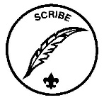**Troop 728/5728**

**Leadership Position Description – TROOP SCRIBE**

**GENERAL INFORMATION**

**Type:** Appointed by the Senior Patrol Leader with approval of Scoutmaster

**Term:** 6 months

**Reports to:** Assistant Senior Patrol Leader

**Description:** The Scribe keeps the troop records. The Scribe records the activities of the Patrol Leaders' Council and keeps a record of dues, advancement, and Scout attendance at troop meetings.

**Comments:** To be a good Scribe you need to attend nearly all troop and Patrol Leaders' Council meetings.

**QUALIFICATIONS**

**Age:** none

**Rank:** none

**Experience:** none

**Attendance:** >50% over the previous six months

**PERFORMANCE REQUIREMENTS**

**Training:** You must attend the troop Junior Leader Training even if you have attended in the past.

**Attendance:** You are expected to attend 65% of all troop meetings, Patrol Leaders' Council meetings, outings, and service projects. If your attendance is low, or if you have three (3) unexcused absences in a row, you can be removed from office.  **Effort:** You are expected to give this job your best effort.

**GENERAL LEADERSHIP RESPONSIBILITIES**

**Uniform:** Set the example by wearing your uniform correctly. This means that you will wear all of the parts of the troop uniform, shirttail tucked in, with all required badges in their correct locations.

**Behavior:** Set the example by living the Scout Oath and Law in your everyday life. Show Scout Spirit in everything you say and do.

**Attendance:** Set the example by being an active Scout. Be on-time for meetings and activities. You must call the Senior Patrol Leader or Scoutmaster if you are not going to be at a meeting or if you suddenly have to miss an outing. You also need to make sure that someone will assume your responsibilities.

**SPECIFIC LEADERSHIP RESPONSIBILITIES**

* Attends and keeps a log of Patrol Leaders' Council meetings
* Records individual Scout attendance and dues payments.
* Records individual Scout advancement progress
* Works with the Troop Committee members responsible for records and finance.

Print Name __________________________ Signature ____________________________ Date ________

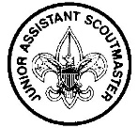**Troop 728/5728**

**Leadership Position Description – JUNIOR ASSISTANT SCOUTMASTER**

**GENERAL INFORMATION**

**Type:** Appointed by the Scoutmaster

**Term:** 1 year

**Reports to:** Scoutmaster

**Description:** The Junior Assistant Scoutmaster serves in the capacity of an Assistant Scoutmaster except where legal age and maturity are required. The JASM must be at least 16 years old and not yet 18. He's appointed by the Scoutmaster because of his leadership ability.

**Comments:** In many cases the JASM has the same responsibilities as an Assistant Scoutmaster.

**QUALIFICATIONS**

**Age:** At least 16 years old

**Rank:** Eagle

**Experience:** Previous leadership positions

**Attendance:** 75% over the previous 6 months

**PERFORMANCE REQUIREMENTS**

**Training:** You must attend the troop Junior Leader Training even if you have attended in the past.

**Attendance:** You are expected to attend 75% of all troop meetings, Patrol Leaders' Council meetings, outings, and service projects. If your attendance is low, or if you have three (3) unexcused absences in a row, you can be removed from office.  **Effort:** You are expected to give this job your best effort.

**GENERAL LEADERSHIP RESPONSIBILITIES**

**Uniform:** Set the example by wearing your uniform correctly. This means that you will wear all of the parts of the troop uniform, shirttail tucked in, with all required badges in their correct locations.

**Behavior:** Set the example by living the Scout Oath and Law in your everyday life. Show Scout Spirit in everything you say and do.

**Attendance:** Set the example by being an active Scout. Be on-time for meetings and activities. You must call the Senior Patrol Leader or Scoutmaster if you are not going to be at a meeting or if you suddenly have to miss an outing. You also need to make sure that someone will assume your responsibilities.

**SPECIFIC LEADERSHIP RESPONSIBILITIES**

* Functions as an Assistant Scoutmaster.
* Performs duties as assigned by the Scoutmaster.

Print Name __________________________ Signature ____________________________ Date ________

**Troop 728/5728 – Leadership Required for Advancement**

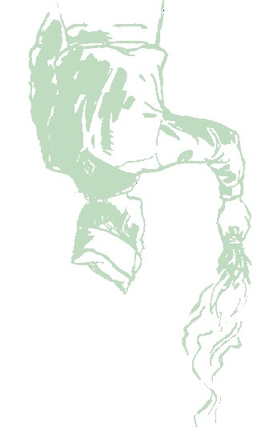

**Troop 728/5728**

**Leadership Position Application**

Your Name:

Age:

Current Rank:

Desired Position:

Previous Positions:

Attendance (last 6 months):

Get from Troop Scribe records

)

(

**Scout's Agreement**

I have read the job descriptions for these positions. I understand the duties and responsibilities and if

selected will carry them out to the best of my ability.

(

Signature)

(

Date)

**Parent's Support Agreement:**

I agree with the commitment my scout is making. I promise to support and encourage my scout in attending training, troop

meetings & activities. I realize that once selected attendance is necessary for the smooth functioning of the troop.

(signature) (Date)

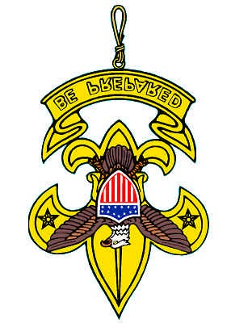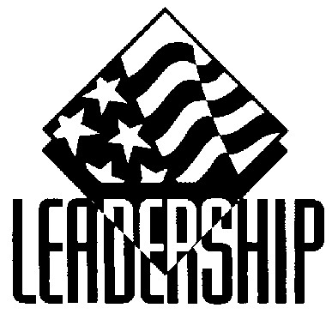

Leadership positions required for rank advancement state that you must actively participate in that position for a specific period of time. This does not mean that you just sew on the path (although you need to do that). You have the responsibility to demonstrate and prove that you have indeed done your best and have actually carried out the responsibilities of your position.

**Start Scout Rank**

While a First Class Scout, serve actively for four months in one or more of the following positions of responsivity:

* Senior Patrol Leader
* Assistant Patrol Leader
* Patrol Leader
* Troop Guide
* Den Chief
* Scribe
* Librarian
* Historian
* Quartermaster
* Bugler
* Junior Assistant Scoutmaster
* Chaplain Aide
* Instructor
* *Carry out a Scoutmaster-assigned leadership project to help the troop

**Life Scout Rank**

While a Start Scout, serve actively for six months in one more of the positions of responsibility listed in requirements for Start Scout, or carry out a Scoutmaster-assigned leadership project to help the troop.

**Eagle Scout Rank**

While a Life Scout, serve actively for a period of six months in one or more of the following positions of responsibility.

* Senior Patrol Leader
* Assistant Patrol Leader
* Patrol Leader
* Troop Guide
* Den Chief
* Scribe
* Librarian
* Historian
* Quartermaster
* Junior Assistant Scoutmaster
* Chaplain Aide
* Instructor