**Trail to First Class Instructor Guide**

Poisonous plants of Oregon

|  |
| --- |
| **Requirements: Tenderfoot**   * 4b. Describe common poisonous or hazardous plants; identify any that grow in your local area or campsite location. Tell how to treat for exposure to them. (pg 127, 191-192) |

The following is the guide for our area of Poisonous plants **in Oregon**.

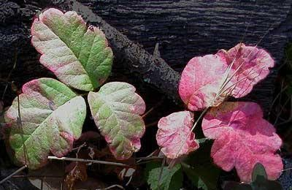**Poison Oak**

Poison Oak is the most notorious plan for causing rashes in the West. (Its counterpart in the east in poison ivy)

Unfortunately, it is also very common and there are opportunities to find it on almost every campout. Like poison ivy, the leaves of poison oak (usually) occur in threes, hence the rule “leaves of three, let it be”.

**Identification:** Usually grows close to the ground, leaves occur in threes and have scalloped edges like oak leaves. At its peak, poison oak leaves are often distinguished by a sticky resin on top of the leaves but you cannot count on this. (The scout book also mentions white berries, but you almost never see them.) There are many plants that look similar to poison oak. It is bad enough that you should just stay away from anything that looks close. In the fall, poison oak leaves often turn bright red. Note that although poison oak is usually a low plant, it can climb other plants and even form large shrubs under the right growing conditions.

**Symptoms**: Skin rash up to 48 hours later, immediately for those very sensitive.

**Treatment**: 1. Change clothes immediately and rinse or shower with large amounts of cool water and soap to rinse off the poison as soon as it is discovered. 2. Keep clothes in a plastic bag to wash separately. 3. Watch for allergic reaction.

You can treat a rash with calamine lotion or a solution of baking soda and water. These will provide comfort but not actually cure the rash.

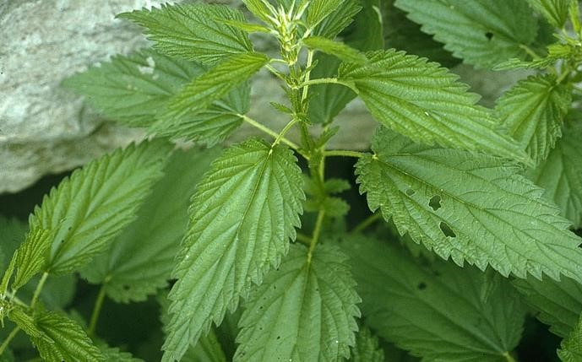**Stinging Nettle**

This is a common plant in the woods. Fortunately, this plant is not very toxic, it's just irritating. The plant causes immediate and occasionally severe burning upon contact with the spines.

**Identification**: Plants are commonly 3-4 feet high, leaves with toothed edges. The distinguishing feature is that the undersides of the leaves (and usually the stems) are covered with tons of tiny, hollow needles or spines.

**Symptoms**: Immediate burning sensation on contact, often with red skin

**Treatment**: There's not much you can do except wait it out because the needles are so tiny. You can try removing needles with tape.

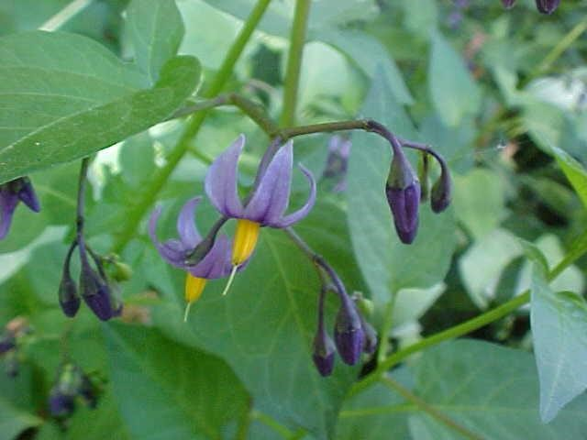**Deadly Nightshade**

Also called belladonna, this plant is not native to Oregon but can be found here frequently. Camp Ireland is rife with it.

**Identification**: Very attractive purple and yellow flowers, in the late summer accompanied by brilliant red oblong fruit. The plant grows in shady areas and has a very distinctively bad smell.

**Symptoms**: Very poisonous; increased heartbeat, in severe cases, paralysis

**Treatment**: It is unlikely that someone would actually eat the berries (due to the smell), but even touching any part of the plant will leave a poisonous reside on the hands. Do not force vomiting, drink plenty of water, wash hands thoroughly with soap and water, and seek treatment for poisoning.

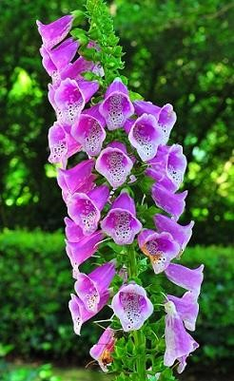**Foxglove**

Also called digitalis, this plant is not native to Oregon but can be found here frequently.

**Identification**: Foxglove bears tall, dramatic spike of tubular flowers with speckled throats. Foxglove blooms in midsummer and is often used in domestic gardens.

**Symptoms**: causes nausea, vomiting and diarrhea including abnormal heart rate and potential seizures.

**Treatment**: Do not force vomiting, wash hands thoroughly with soap, and seek treatment for poisoning.

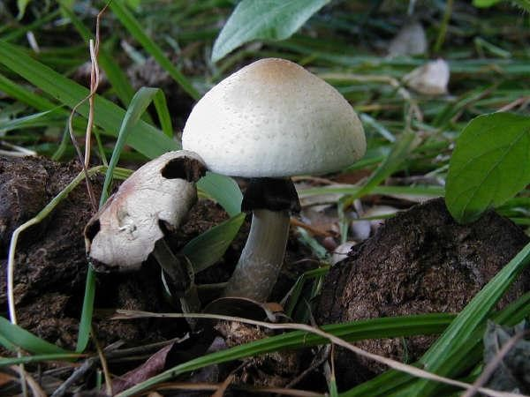**Mushrooms**

There are many varieties of mushrooms, ranging from edible to deadly poisonous. The general rule is, don’t eat or even touch mushrooms in the wild unless you are an expert.

**Identification**: Mushrooms come in all sorts of shapes and colors, but commonly a cap on a stalk. There is no foolproof rule to distinguish poisonous varieties from edible ones.

**Treatment**: If eaten, drink water, rinse out mouth (but do not force vomiting). Wash any parts of the body that might have touched the mushroom. Collect a sample of the mushroom if possible. Call your local poison control center, seek treatment immediately.

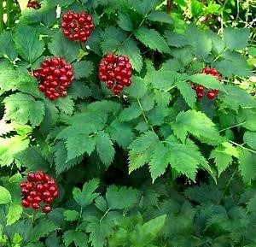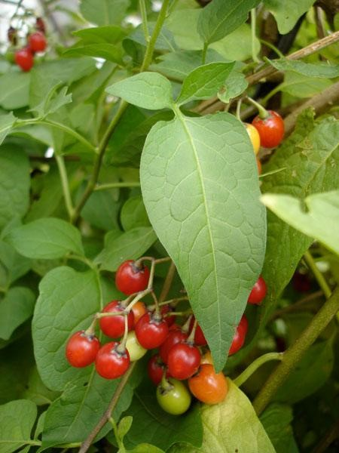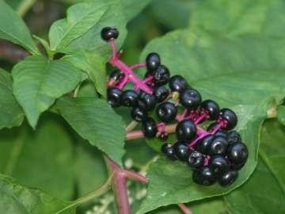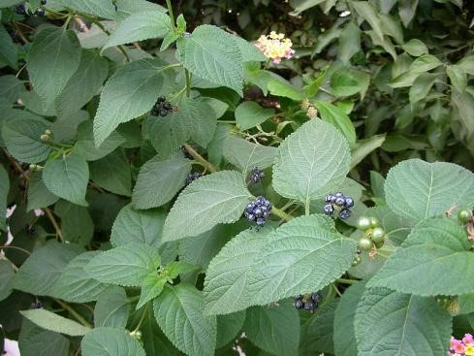**Berries**

There are many varieties of berries, ranging from edible to poisonous. The general rule is, don’t eat or even touch berries in the wild unless you are very certain of the identification of the berry. Some are not native to Oregon but can be found here.

* Some poisonous berries (pictured clockwise)
* Baneberry
* Bitter nightshade
* Lantana, or red sage
* Pokeweed

**Identification**: Berries grow on all shapes of bushes and trees and come in all sorts of shapes and colors. Berries of the same color can be either edible or poisonous, so it is very important to identify the berry and the plant they are growing on. There is no foolproof rule to distinguish poisonous varieties from edible ones. Though white berries are never edible.

**Symptoms**: Mile to severe upset stomach, nausea, for more poisonous varieties convulsions or even paralysis.

**Treatment**: If eaten rinse out mouth (but do not force vomiting unless told to by a health care professional). Collect a sample of the berry if possible. Call your local poison control center, seek treatment immediately.

References: [Oregon Poison Center](http://www.ohsu.edu/poison/documents/toxicPlants.pdf)

**Pictures to quiz scout in identification of plants**

