Trail to First Class Instructor Guide
Basic Lashing

Requirements: First Class:
- 3a. Discuss when you should and should not use lashings. (pg 371-378)
- 3c. Demonstrate type the square, shear, and diagonal lashings by joining two of more poles or staves together. (see pg 373-376)
- 3d. Use lashings to make a useful camp gadget or structure. (pg 371-378)

EDGE Method of Teaching  Explain how it is done  Demonstrate the steps  Guide the learners as they practice  Enable learners to succeed on their own | Components of a Lashing  Spar – a pole or staff used as structural members of a pioneering project.  Wrap – a turn made around the two spars to hold the spars tightly together.  Frap – a turn made around the Wraps and between the spars. It pulls the wraps tight. Two fraps are used in a typical lashing.
Proper Use of a Lashing
- Use lashings to build structures without nails.
- Use only correct lashing for the type of binding required.
- Use only approved materials.
- Always untie all structures when done.
- Practice leave no trace principles.

Square Lashing (page 373-374)
A square lashing is used for binding two poles at right angles together.
- Tie clove hitch around bottom pole, near cross piece.
- Make three tight wraps around both poles. The rope should be wrapped on the outside of the previous wrap on the top pole, and inside the previous wrap on the bottom pole.
- Wind two fraps around the wraps, pulling the rope tight.
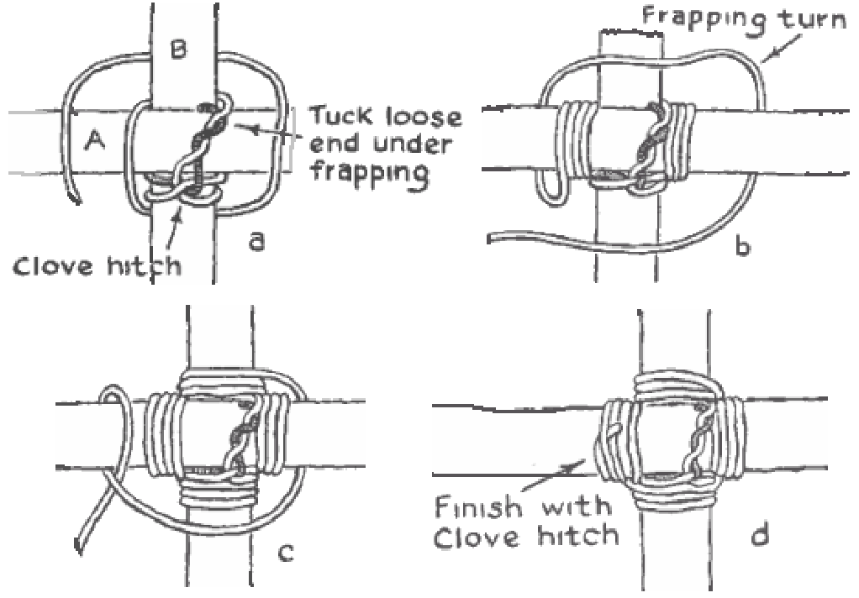
- Finish with a clove hitch around the top pole.

Clove Hitch (page 368)
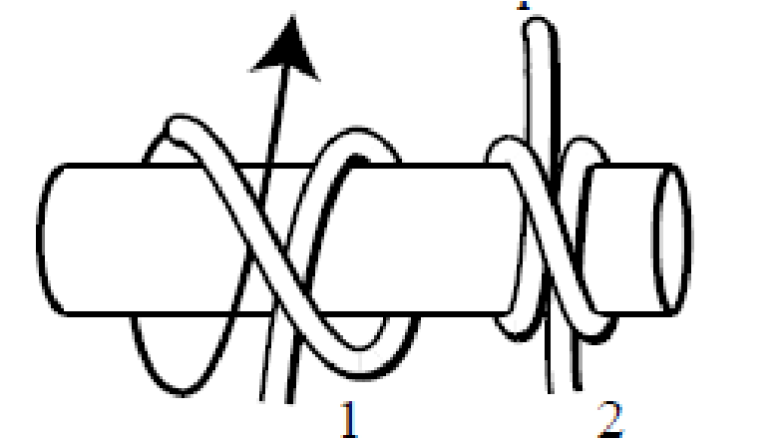
A clove hitch holds a line to a post when being pulled in two directions or to start or end lashings.
Timber Hitch (page 367)
A Timber Hitch ties a rope to a round object like a tree or log and is used to start a diagonal lashing.
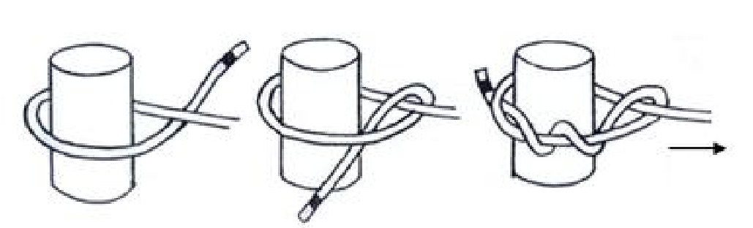
Shear Lashing (page 376)  A shear lashing binds the ends of two poles together and can be used as an A-frame.  - Tie clove hitch around one pole.  - Then make 3 wraps around both poles.  - Tighten the lashing with a by frapping taking the rope down between the two poles, around the wrap, and back up between the poles at the other end of the wraps.  - Finish with a clove hitch around the other pole, at the opposite end of the wraps.  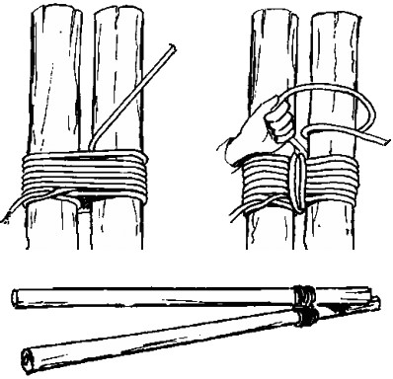 | Diagonal Lashing (page 376)  Diagonal lashing is used to bind poles together that cross each other but do not touch when their ends are lashed in place in a structure.  - Tie a timber hitch diagonally around both poles.  - Start the wrapping turns on the opposite diagonal direction to the timber hitch.  - Take 3 wrapping turns; keep the wrapping turns parallel; pull each wrapping turn tight.  - Start the second set of three wrapping turns across the first three by going past and around the vertical pole.  - Start the 2-3 frapping turns by going past and around one of the poles. [NOTE] Going around the pole allows the direction of the rope to be changed without crossing the wrapping turns diagonally.  - End the lashing with a clove hitch. Lock the half hitch tight against the lashing by working it tight.  - Work the second half hitch tight against the first half hitch so that the clove hitch is locked tight against the lashing.  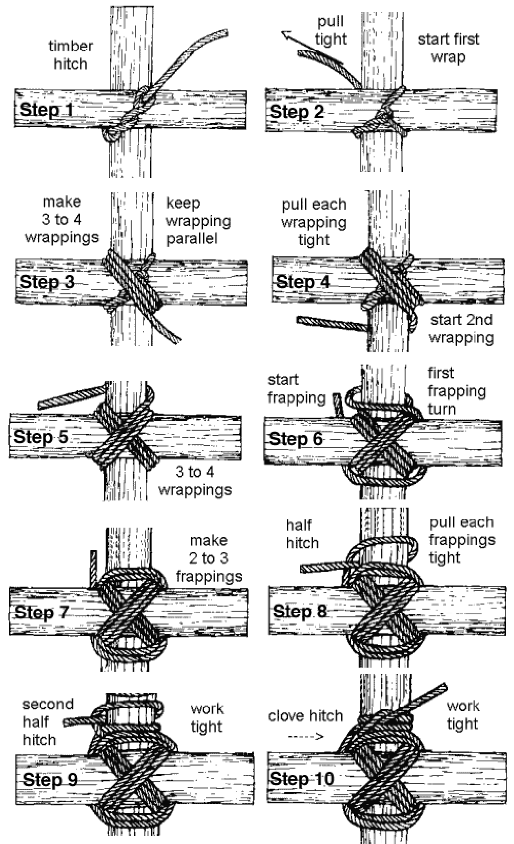

Tripod Lashing (page 377)  A tripod lashing binds three poles together using a similar lashing like a shear lashing. The poles can be spread apart and used as a tripod.  - Lay three poles along side each.  - Tie a clove hitch around one outside pole.  - Loosely wrap the rope around the poles 5-6 times laying the wraps neatly along side one another. The wraps should weave on opposite sites of the center pole, similar to a figure eight.  - Make two fraps on both sides of the center pole.  - End with a clove hitch around the other outside pole.  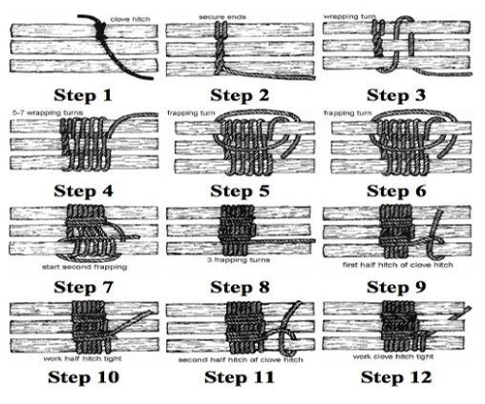  Set up the tripod by crossing the outside poles so that the cross point of the poles is under the center pole. Crossing the outside poles under the center pole causes part of the load that is placed on the tripod to be taken up by the wood to wood contact of the poles.  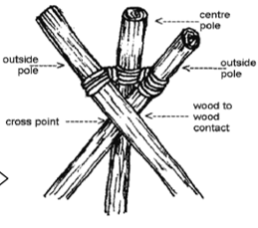 | Round Lashing (page 377)  A round lashing binds the ends of two poles together to make a longer pole.  - Tie a clove higch round the bottom pole. Wind the rope around both poles six or seven times. There are NO fraps in this lashing so wraps must be very tight.  - Finish with two half hitches round both poles.  - Make a second round lashing further along the poles to keep the poles from twisting.  - The lashing can be tightened by driving a small wooden peg (wig) between the poles.  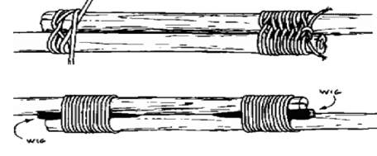

DEMONSTRATE HOW TO Tie Lashing
(Instructor Outline)

Requirements: First Class:
- 3a. Discuss when you should and should not use lashings. (pg 371-378)
- 3c. Demonstrate type the square, shear, and diagonal lashings by joining two of more poles or staves together. (see pg 373-376)
- 3d. Use lashings to make a useful camp gadget or structure. (pg 371-378)

Learning Objective:
At the end of this period of instruction, the scout will be able to properly tie and use a square, shear and diagonal lashing on his own.

Enabling Learning Objectives:

- Explain when to use a lashing and when not use a lashing. - See page.
- Using the EDGE method teach how to tie a clove hitch. - explain when to use it.
- Using the EDGE method teach how to tie a timber hitch. – explain when to use it.
- Using the EDGE method to teach how to tie a square lashing, a shear lashing, a diagonal lashing and a round lashing.

Equipment Needed to Teach:
Explain how it is done
Demonstrate the steps
Guide the learners as they practice
Enable learners to succeed on their own
Several round poles
Natural fiber rope

