Trail to First Class Instructor Guide
Basic Knots and Rope Care

Requirements
Scout:
- 4a. Show how to tie a square knot, tow half-hitches, and a taut-line hitch. Explain how each knot is used. Demonstrate how to tie a square knot. (pg 365-367)
- 4b. Show the proper care of rope by learning how to whip and fuse the ends of different kinds of rope (pg 361-362)
Tenderfoot:
- 3a. Demonstrate a practical use of the square knot (see pg 365)
- 3b. Demonstrate a practical use of two half-hitches (see pg 366)
- 3c. Demonstrate a practical use of the taut-line hitch (see pg 367)
Second Class:
- 2f. Demonstrate tying the sheet bend knot. Describe a situation in which you would use this know (see pg 370)
- 2g. Demonstrate tying the bowline know. Describe a situation in which you would use this knot. (see pg 369-370)
First Class:
- 3b. Demonstrate tying the timber hitch and clove hitch (see page 367-368)
Whipping and Fusing (page 361)  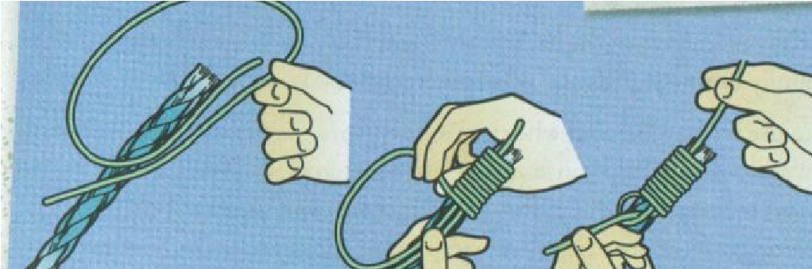  A permanent way to protect ropes from unraveling. Remember to cut away any part that has unraveled. | Square Knot (page 365)  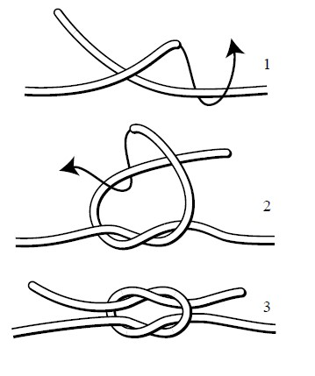  The square knot is used as a binding knot to connect two ends of the same diameter rope (single line). Use a square to bind bandages, packages or securing objects.

Two Half Hitches (page 366)  A hitch knot ties an object to a post or ring, and the two half hitch knot will slide to adjust the loop and will only attach to an object in one direction at a fixed length.  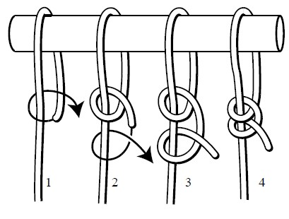 | Taut-line Hitch (page 367)  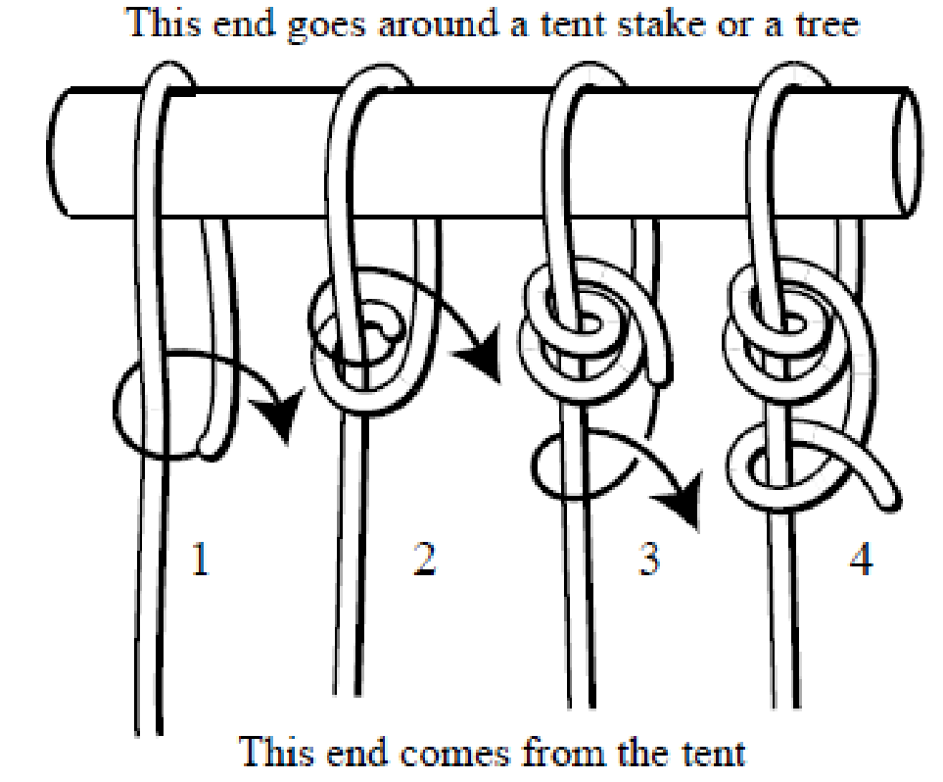  A hitch knot ties an object to a post or ring, and the Taut-line hitch knot will slide to adjust the tension of the line between the object and the post or stake. Thus the line will become shorter and have a fairly secure loop.

Bowline (page 369)  A bowline is used to make a non-slip loop at the end of a rope. It is so dependable it is referred to as a rescue knot since it can be tied around someone to or oneself one handed and used to lift people out of dangerous situations.  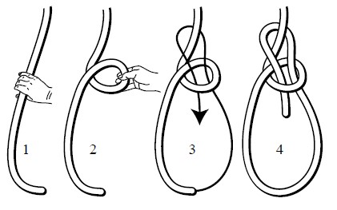 | Timber Hitch (page 367)  A Timber Hitch ties a rope to a round object like a tree or log and is used to start a diagonal lashing.  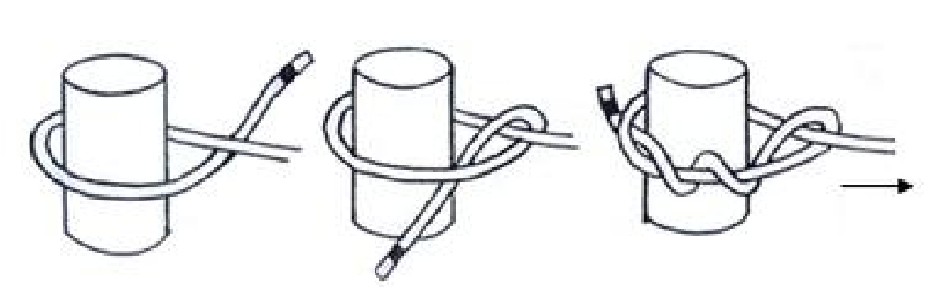
Clove Hitch (page 368)
A clove hitch holds a line to a post when being pulled in two directions or to start or end lashings. 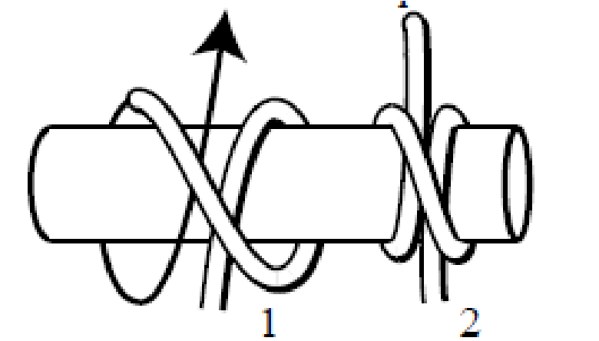

Explain how it is done
Demonstrate the steps
Guide the learners as they practice
Enable learners to succeed on their own

DEMONSTRATE HOW TO WHIP AND FUSE ROPE
(Instructor Outline)
Requirements
Scout:
- 4b. Show the proper care of rope by learning how to whip and fuse the ends of different kinds of rope (pg 361-362)

Learning Objective: At the end of this period of instruction, the scout will be able to properly whip or fuse the ends of a rope on his own.

Enabling Learning Objectives:
- Explain why rope ends must be fused, whipped or back spliced.
  - Rope is made from twisted or woven fiber and has a tendency to unravel.
- Explain field expedient, temporary methods to whip the end of a rope.
  - Wrap end with duct tape.
  - Tie an overhand knot at each end.
- Explain and show the two types of rope.
    - Natural fiber, non-natural fiber
- Explain which type of rope should not be fused, and should be whipped or spliced. - Manila, sisal, hemp, cotton or other natural fibers.
- Explain which type of rope is best to fuse.
  - Plastic, nylon rope that melts when exposed to high heat.
- Using the EDGE method teach how to fuse rope
  - Well ventilated area
  - Sharp knife to cut away frayed rope
  - Lighted match or candle to melt and fuse strands together. - DO NOT TOUCH HOT ENDS UNTIL THEY COOL!
- Using the EDGE method teach how to whip the ends of a rope
  - -Sharp knife to cut away frayed rope
  - -Two 2 foot pieces of waxed strong string.

Equipment Needed to Teach:
Sharp Knife
Explain how it is done
Demonstrate the steps
Guide the learners as they practice
Enable learners to succeed on their own
Whipping string (waxed dental floss)
Lighter & Candle
18” natural fiber rope/Scout
12” man made 3-strand rope/Scout
Samples of Fused, Whip and Spliced ends

DEMONSTRATE HOW TO TIE BASIC KNOTS
(Instructor Outline)

Requirements
Scout:
- 4a. Show how to tie a square knot, tow half-hitches, and a taut-line hitch. Explain how each knot is used. Demonstrate how to tie a square knot.
- 4b. Show the proper care of rope by learning how to whip and fuse the ends of different kinds of rope (pg 361-362)
Tenderfoot:
- 3a. Demonstrate a practical use of the square knot (see pg 365)
- 3b. Demonstrate a practical use of two half-hitches (see pg 366)
- 3c. Demonstrate a practical use of the taut-line hitch (see pg 367)
Second Class:
- 2f. Demonstrate tying the sheet bend knot. Describe a situation in which you would use this know (see pg 370)
- 2g. Demonstrate tying the bowline know. Describe a situation in which you would use this knot. (see pg 369-370)
First Class:
- 3b. Demonstrate tying the timber hitch and clove hitch (see page 367-368)

Learning Objective:
At the end of this period of instruction, the scout will be able to properly tie the knots on his own and explain their common uses.

Enabling Learning Objectives:
- Explain the how to care for a rope to maintain its strength.
  - keep it coiled.
  - keep it dry and off the ground when stored.
  - keep the ends whipped, fused or spliced.
- Explain how to choose the size of rope to match the job.
- Explain the common uses of each knot.
- Use the EDGE method to teach each of the knots one at a time.

Equipment Needed to Teach:
Two pieces of 18” or longer rope per scout
A wood pole
A tent stake

Explain how it is done
Demonstrate the steps
Guide the learners as they practice
Enable learners to succeed on their own

revised 1/2024

