**Trail to First Class Instructor Guide**

Flag Ceremony

|  |  |
| --- | --- |
| **Requirements**  **Scout:**   * 1c Demonstrate the Scout sign, salute, and handshake. Explain when they should be used. (pg 18-19) * 1f Repeat from memory the Pledge of Allegiance. In your own words explain the meaning. (pg 60)   **Tenderfoot**   * 7a Demonstrate how to display, raise, lower and fold the U.S flag. (pg 58-60)   **Second Class:**   * 8a Participate in a flag ceremony for your school, religious institution, chartered organization, community, or Scouting activity. (pg 60-61) * 8b Explain to your leader what respect is due the flag of the United States. (pg 56-62) | |
| **EDGE** Method of Teaching  **E**xplain how it is done  **D**emonstrate the steps  **G**uide the learners as they practice  **E**nable learners to succeed on their own | **Flying the Flag** (page 56-62)  The American Flag –  - Never touches the ground   * Flown outside from sunrise to sunset unless lit. * Stars are always on top, unless in distress signal. * Ceremoniously raised briskly and lowered slowly. * Should only be flown if in respectable condition. * In Stand, displayed on right side of speaker. * Always walked ahead, to the right and above all other flags. * Always raised first, lowered last with other flags * For half-mast, it should be raised to top first then lowered to half-mast.   Scouts -   * Serious, respectful behavior. Never make noise. * No non-scout hats and Uniforms uncovered. |
| **Folding the Flag** (page 59)  Hold the flag at waist level. Preferable to have three people. The person holding the end with Blue and stars stays in place, while the others move. The American flag is always folded in a triangle so the stars and blue field is showing when folded. No red or white stripe should be exposed if folded correctly. |
| **American Flag Standards of Respect**    The Flag Code, which formalizes and unifies the traditional ways in which we give respect to the flag, also contains specific instructions on how the flag is **not** to be used. They are:     * The flag should never be dipped to any person or thing. It is flown upside down only as a distress signal. * The flag should not be used as a drapery, or for covering a speaker’s desk, draping a platform, table, or for any decoration in general. * The flag should never be used for any advertising purpose. * The flag should not be used as part of a costume or athletic uniform, except that a flag patch may be used on the uniform of military personnel, fireman, policeman and members of patriotic organizations. * The flag should never have placed on it, or attached to it, any mark, insignia, letter, word, number, figure, or drawing of any kind. * The flag should never be used as a receptacle for holding, carrying, or delivering anything. * When the flag is lowered, no part of it should touch the ground or any other object; it should be received by waiting hands and arms. * To store the flag it should be folded neatly and ceremoniously. * The flag should be cleaned and mended when necessary. * When a flag is so worn it is no longer fit to serve as a symbol of our country, it should be destroyed by burning by an authorized organization in a dignified manner. | |

# Proper Scout Actions for Salute and Attention

Scouts who are attending official scout functions, troop meetings and saluting the flag, should understand and practice the following positions for a professional and respectful appearance.

# Scout Salute

When the command “Salute” is given, scouts should stand at ATTENTION and SALUTE. The flag of the United States of America is saluted as it is raised and lowered.

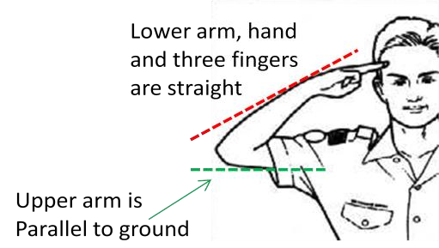

* The scout salute is held until the flag is unsnapped from the halyard or through the last note of music, whichever is the longest.
* The scout salute is directed at the flag.

The scout salute is started at command of the person in charge, and held until the command of “TO” is given.

# Scout Attention

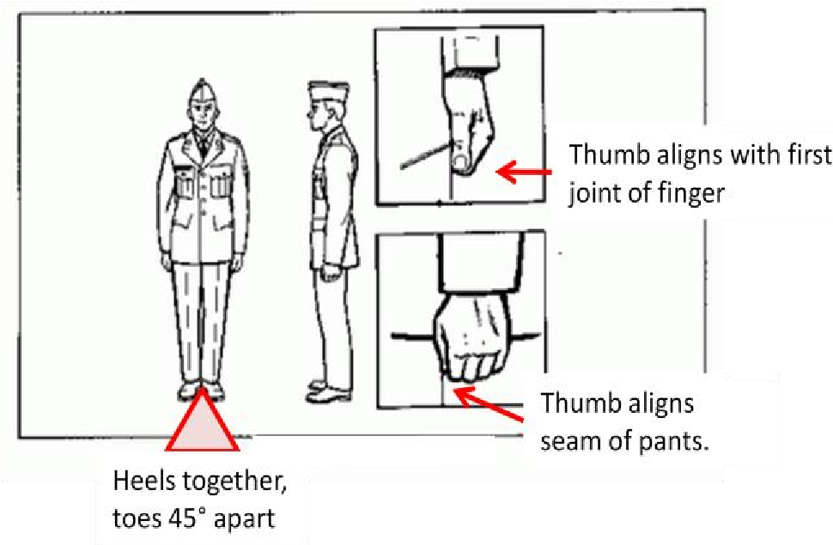

When the command “Attention” is given, scouts should stand and assume the following stance.

* Stand tall, hips, shoulders square and level.
* Legs are straight, without locking knees.
* Heels together and aligned, the toes pointed out equally, forming 45degree angle.
* Keep head aligned to face directly forward. • Arms hang straight, elbows slightly bent.
* Hand should be made into fists like you are holding a roll of coins. Keep thumbs straight pointing down and knuckle pointing forward (do not tuck or curl thumb). Thumb should be aligned with the seam of pant.
* Remain silent and do not move. Allowed to breathe, blink and swallow.

The position of Attention is held until another command for action is given by the individual in charge.

# Parade Rest

When the command of “Parade REST”, which can only be from the position of ATTENTION is called

* Move the left foot about 10 inches to the left of the right foot. Keep the legs straight without locking the knees, resting the weight of the body equally.
* Simultaneously, place the hands at the back and centered on the belt. Keep the fingers of both hands extended and together, interlocking the thumbs so that the palm of the right hand is outward.
* Keep head and eyes as in the position of *attention*. Do not talk or move unless directed.

# At Ease

On the command AT EASE, you may move; however, he must remain standing or sit in place. Talking and other movements are allowed in place.

# Scout Sign

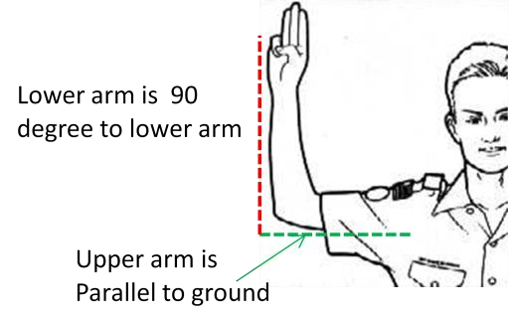

Scout sign shows you are a scout and should be raised when reciting the Scout oath and law. When a scout raises the sign all scouts should raise their sign and come to silence.

* Correct posture has the upper arm parallel to ground, and the lower arm 90° to the upper arm.

**DEMONSTRATE HOW TO RAISE, LOWER and Fold the FLAG**

(Instructor Outline)

|  |
| --- |
| **Requirements**  **Tenderfoot**   * 7a Demonstrate how to display, raise, lower and fold the U.S flag. (pg 58-60) |

**Learning Objective:** At the end of this period of instruction, the scout will be able to properly raise, lower and fold the American flag as well as participate as a color guard in a flag ceremony.

**Enabling Learning Objectives:**

1. Explain American flag etiquette and respect.
   1. federal law governs the display of our national flag, this ensures that it will be treated with the respect it is due.
2. Use the EDGE method to teach how to fold an American Flag
   1. See fact sheet on information
3. Use the EDGE method to teach how to raise and lower an America Flag - See fact sheet on information
4. Use the EDGE method to teach how to perform as a color guard in a flag ceremony.
   1. Minimum color guard size is 4 individuals, maximum is 6.
   2. Be prepared! Know the ceremony area and equipment.
5. Know where to start, o Know approach path, o Know how rope is attached and how the clips work.

**Equipment Needed to Teach**:

American Flag

|  |
| --- |
| **E**xplain how it is done  **D**emonstrate the steps  **G**uide the learners as they practice  **E**nable learners to succeed on their own |

Flag Pole

# For Raising the Flag

|  |  |
| --- | --- |
| Verbal Command | Then … Color Guard actions |
| *Audience please rise* | * Color Guard assembles at PARADE REST! |
| *Troop attention* | * Stand at Attention |
| *Color Guard forward march* | * Start with RIGHT foot and start walking in unison equal space between shoulders. Looking straight ahead. |
| *Halt* | * Stop walking on left foot |
| *Color Guard prepare to present to the colors* | * One individual on each end, one in the middle unfold the flag. The person with the stars, stands still. The others walk as flag is unfolded. * At the same time, the fourth person removes the rope from the pole and prepare clips. * The two individuals on the end of the flag prepare to present the color, by having a hold of each corner. |
| *Present the colors* | * The individuals at the ends snap open the flag and hold at an angle for the audience to see. |
| *Scout hand salute* | * Commander salutes, * Person that was in the middle now connects flag to the rope clips. * One person still holds the end of the flag above waist level ensuring it does not touch the ground. |
| *Raise the colors, Bugler sound off* | * The color guard that untied the rope, and a second guard raise the flag. One keep the rope separated from tangling. * Once individual duty is complete, reform ranks at attention. Once at attention, initiate “Salute”. |
| *Please join me in the pledge of allegiance* | * Join in reciting the pledge of allegiance. |
| *To* | * Stop salute stand at attention. |
| *Color Guard about* | * Place right foot behind left to prepare. |
| *Face* | * In unison turn 180 to right. |
| *Forward march* | * Start with RIGHT foot and start walking in unison. Looking straight ahead. |
| *Halt* | * Stop walking at the same time stay at attention |
| *About [pause] face* | * In unison turn 180 to right and return to attention. |
| *Troop At Ease* | * Stay at attention |
| *Color Guard dismissed* | * Return to ranks |

**For Lowering the Flag**

|  |  |  |
| --- | --- | --- |
| Verbal Command | Then … Color Guard actions | |
| *Audience please rise* | * Color Guard assembles at PARADE REST! | |
| *Troop attention* | * Stand at Attention | |
| *Color Guard forward march* | * Start with RIGHT foot and start walking in unison equal space between shoulders. Looking straight ahead. | |
| *Halt* | * Stop walking on left foot | |
| *Color Guard Salute* | * Salute | |
| *Color Guard prepare to retire the colors* | * All color guards stop salute. Two individuals remove the rope from the pole and prepare to lower. Stand facing each other holding the rope in both hands so the bottom of the rope is taunt between them | |
| *Scout hand salute* | * Stand at attention or holding the rope. | |
| *Color Guard Retire the colors, Bugler sound off* | * Slowly lower the flag. * Once the flag is within reach the next individual receives the end of the flag preventing it from going below waist level and will walk back away from the pole as it continues to lower. | |
|  | * Once the rest of the flag reach the waist level the next person retrieves the blue end of the flag. The person with the stars, stands still. The others walk as flag is folded. | |
|  | * Once unclipped commander can give “TO” command | |
| *To* | * The person managing the rope secures the rope to the pole and then helps the other two fold the flag. The person in the middle makes sure the flag is a tightly aligned fold each time. | |
|  | * Only three people help with folding, if using additional guards. Once rope is secure, reforms guard ranks and stand at attention. |
|  | * Once done folding each person reforms ranks. |
| *Color Guard about* | * Place right foot behind left to prepare |
| *Face* | * In unison turn 180 to right |
| *Forward march* | * Start with RIGHT foot and start walking in unison. Looking straight ahead. |
| *Halt* | * Stop walking at the same time stay at attention |
| *About [pause] face* | * In unison turn 180 to right and return to attention |
| *Troop At Ease* | * Stay at attention |
| *Color Guard dismissed* | * Return to troop ranks |

*revised 1/2024*